Sources for dataset

1 Conflict Data

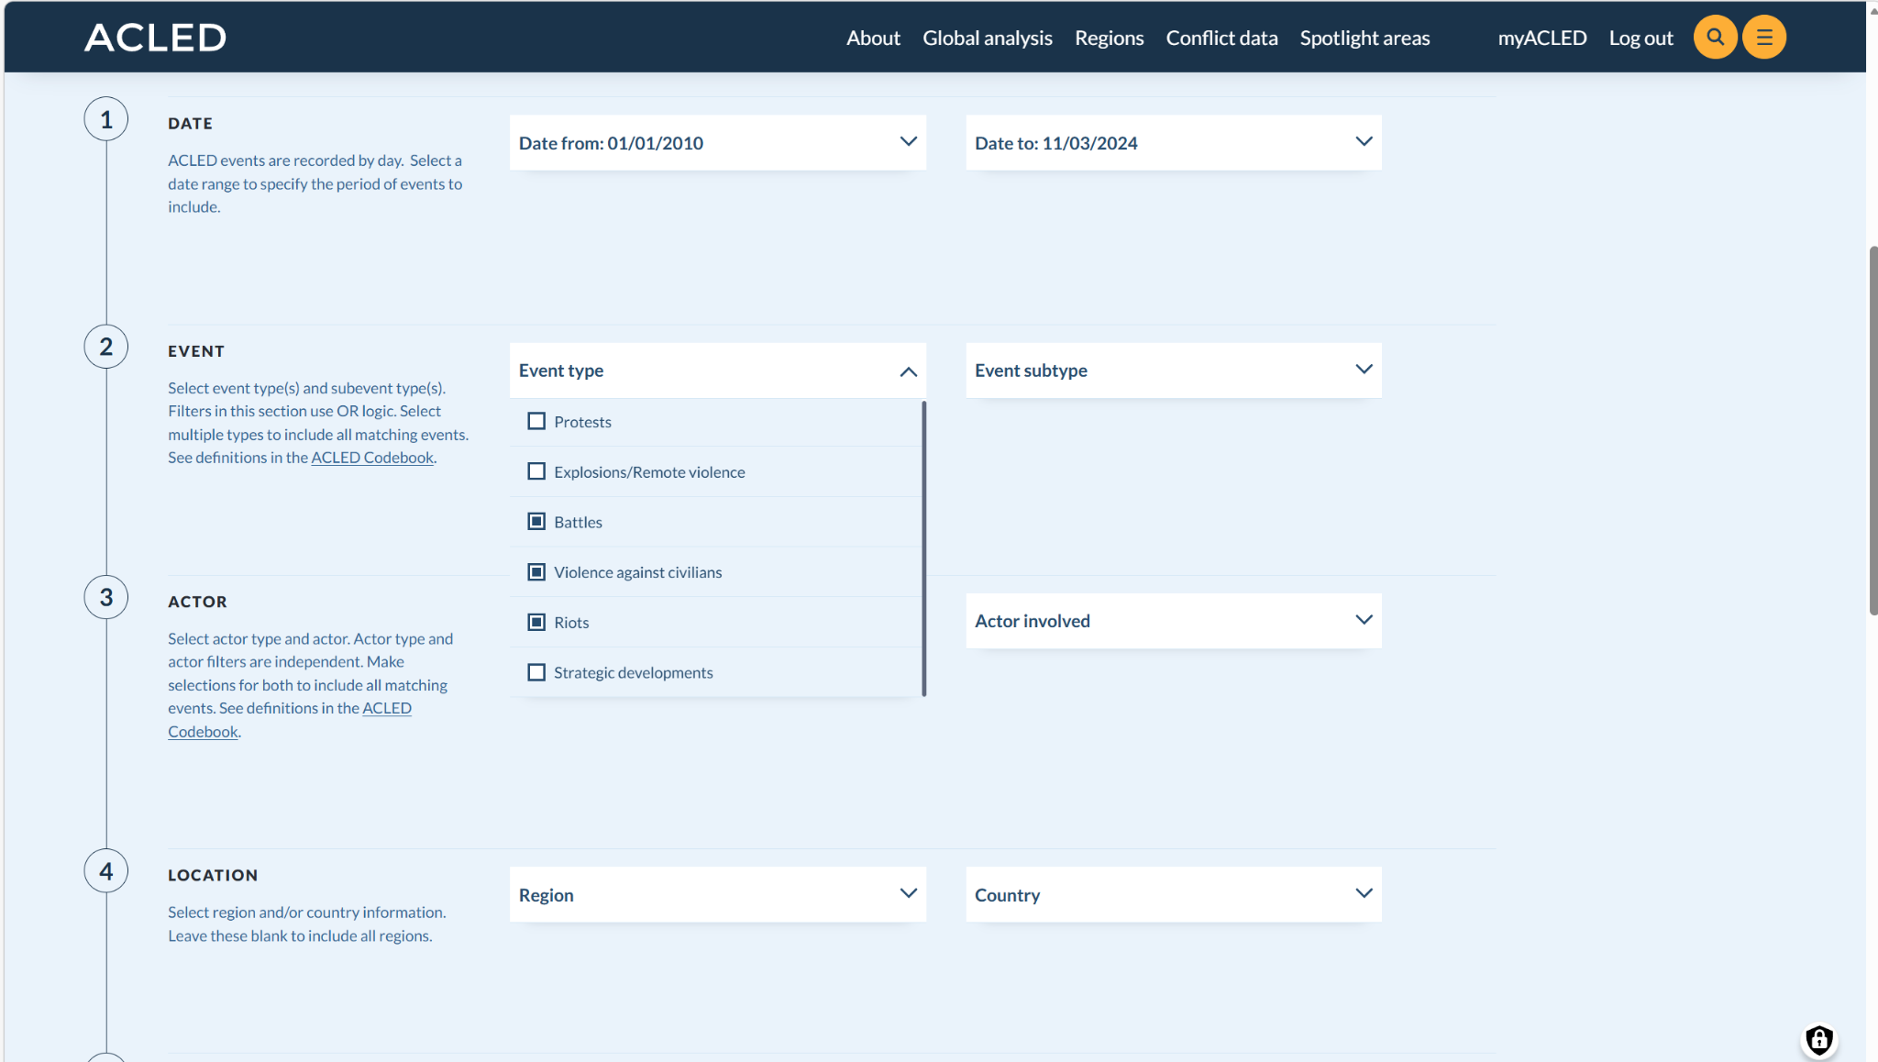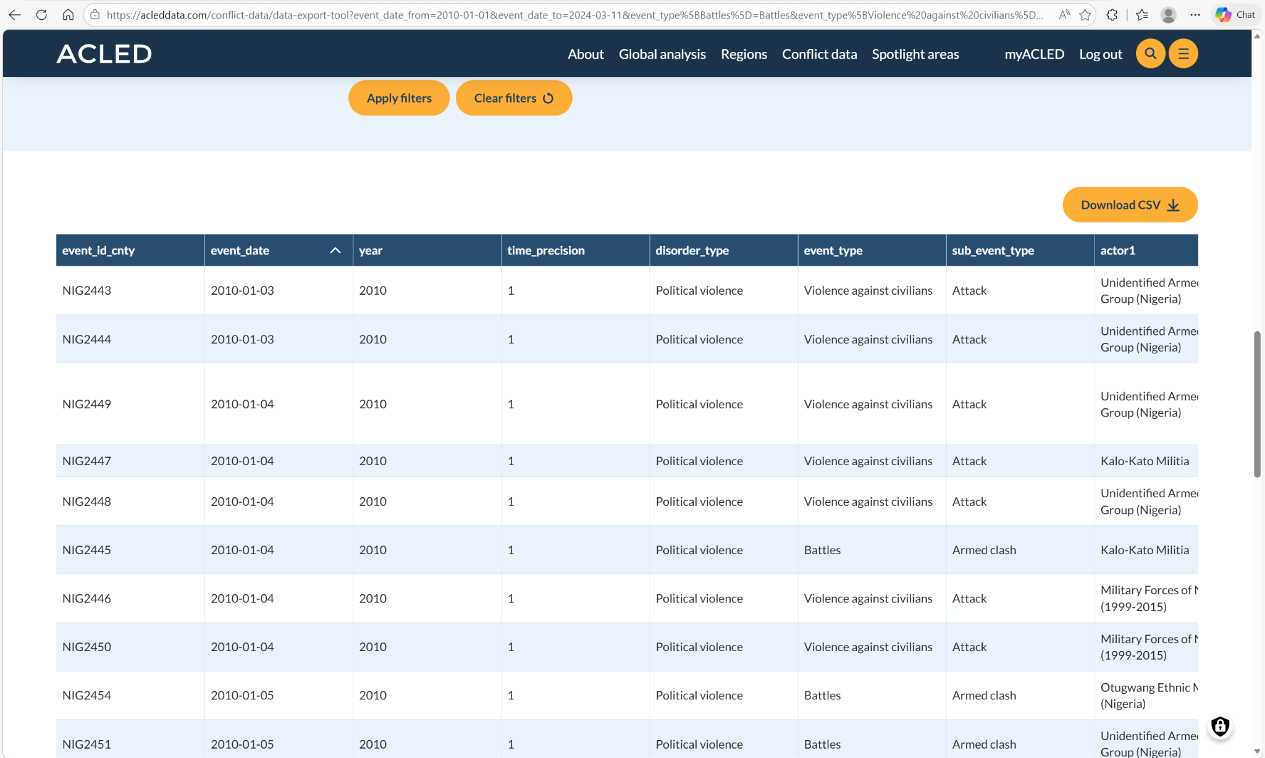
Was sourced From Armed Conflict Location & Event Data Project (ACLED)

2 Economic Data

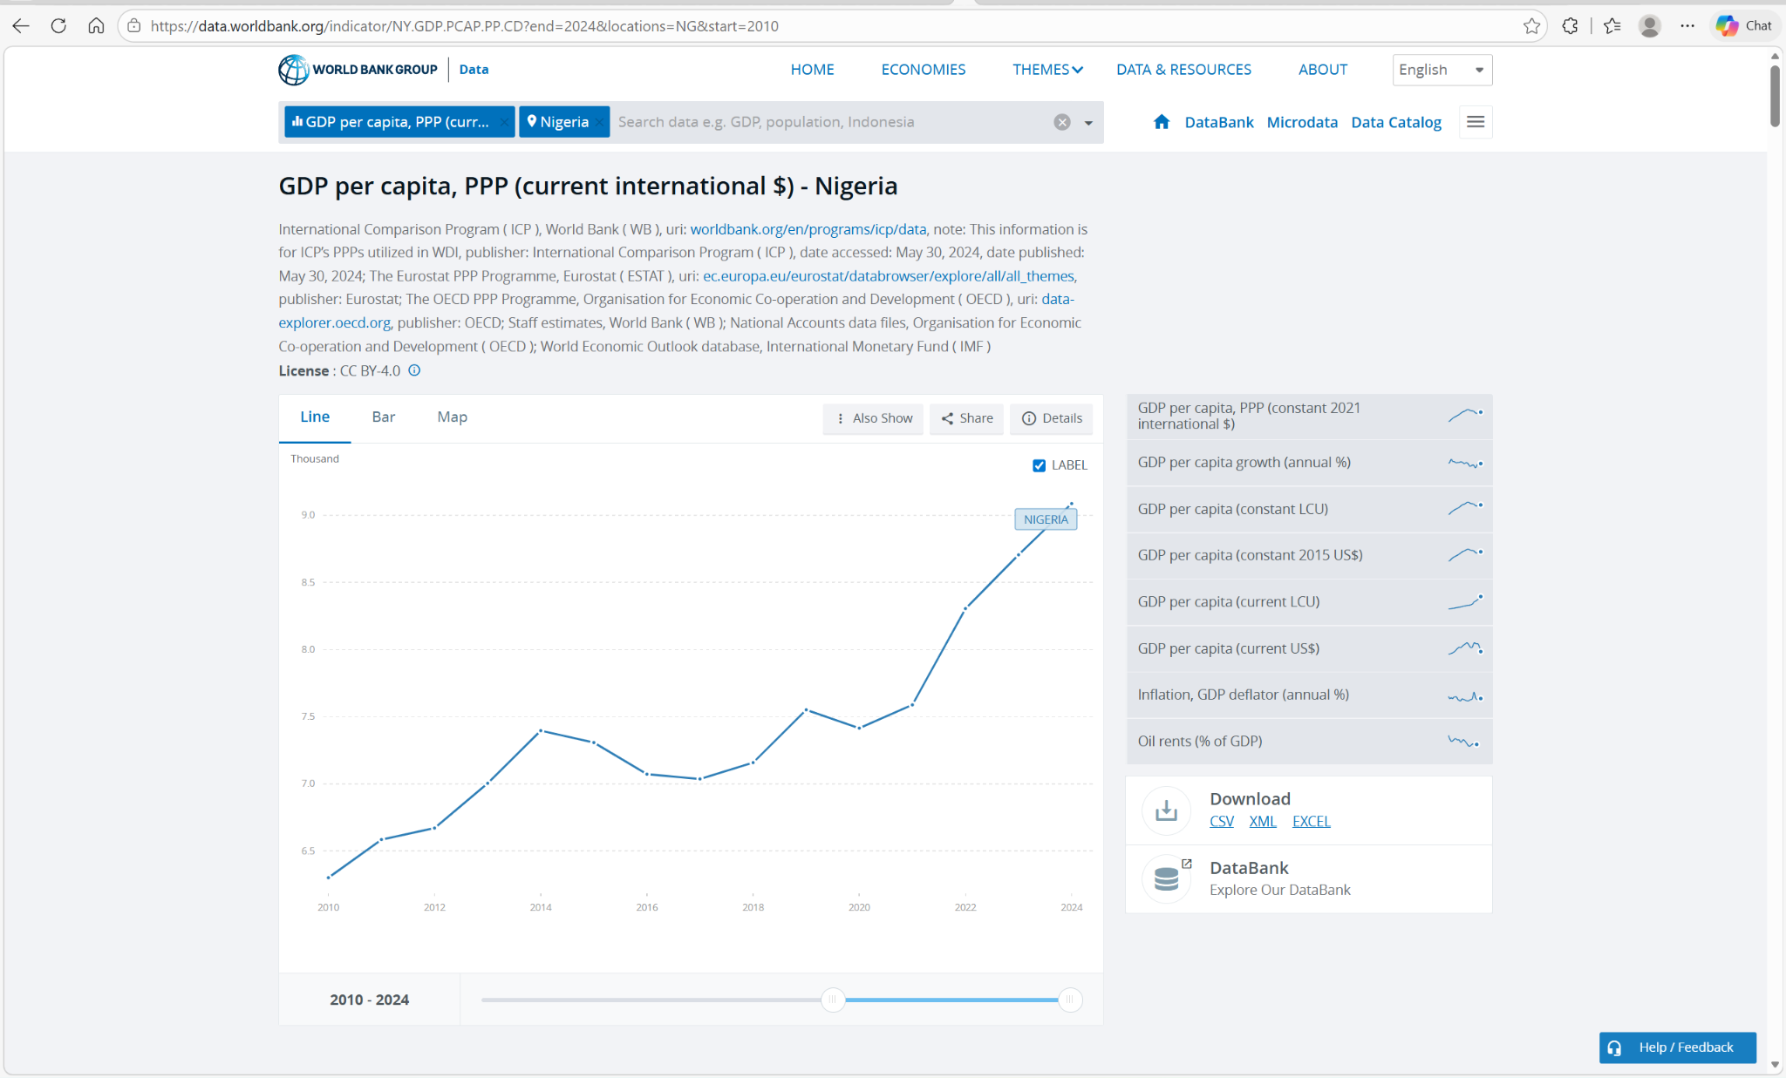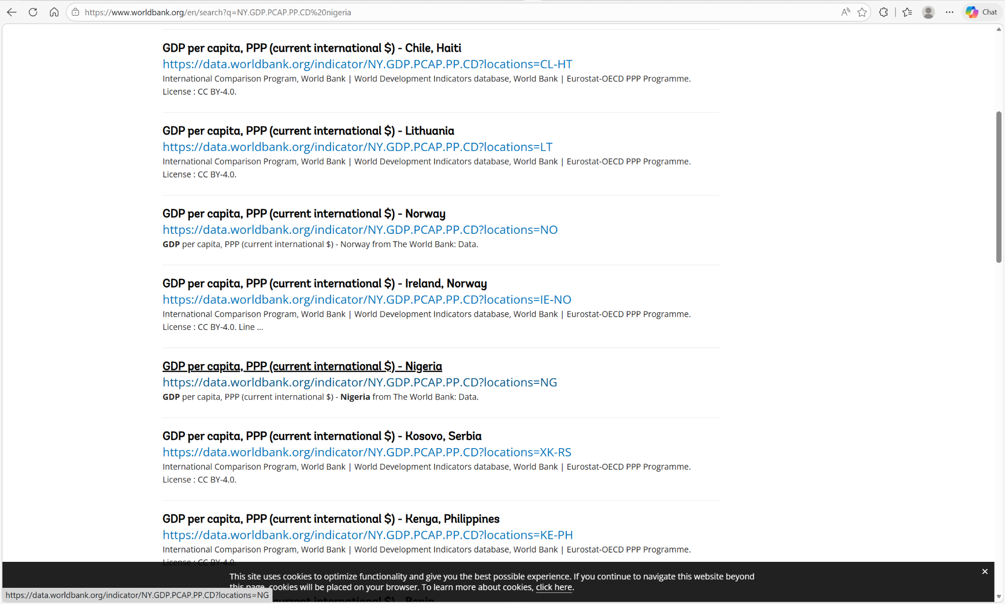
was sourced from World Bank Open Data

3 Food Price Data
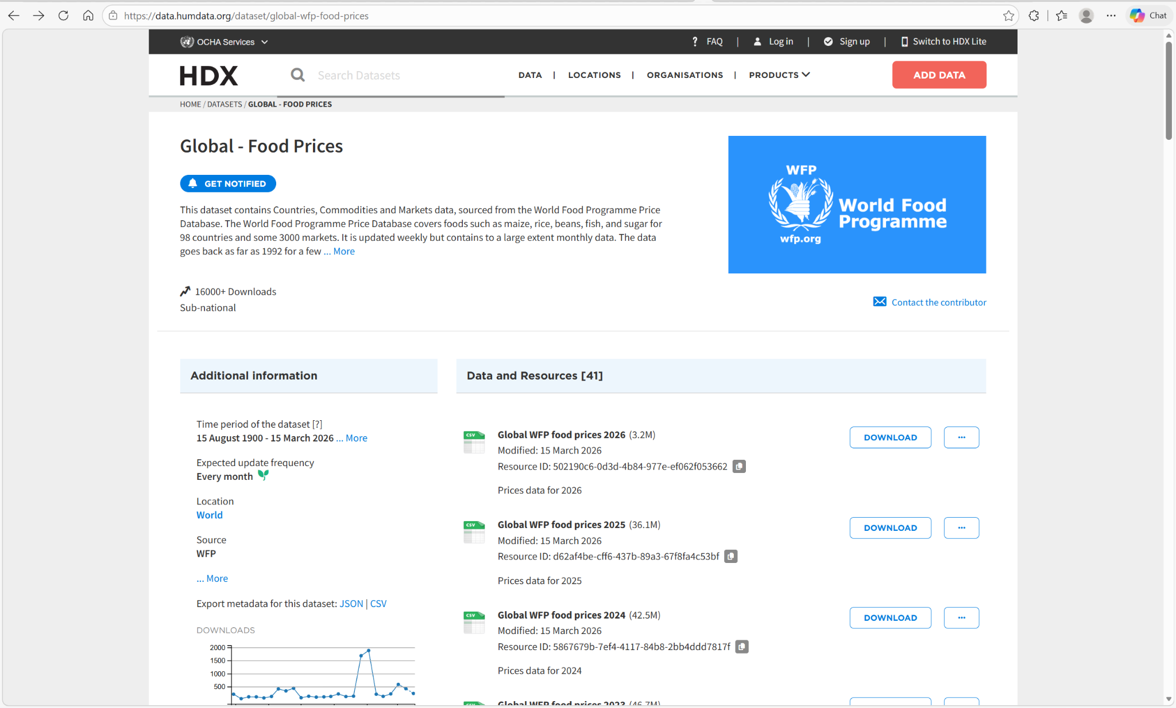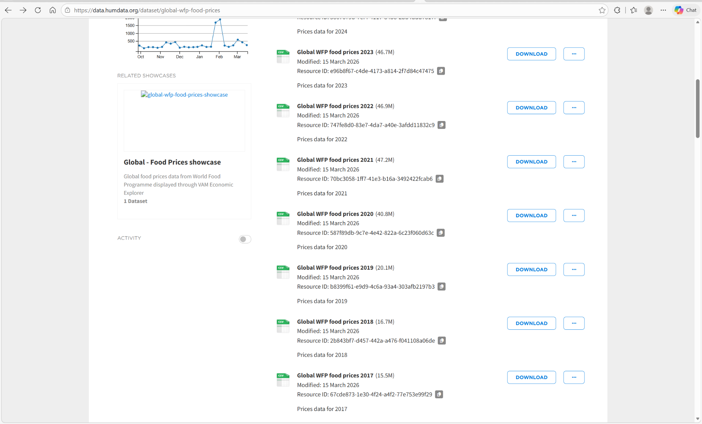

Was sourced From World Food Programme VAM Food Prices
Hosted on Humanitarian Data Exchange
Can also be gotten from kaggle
4 Disaster Data

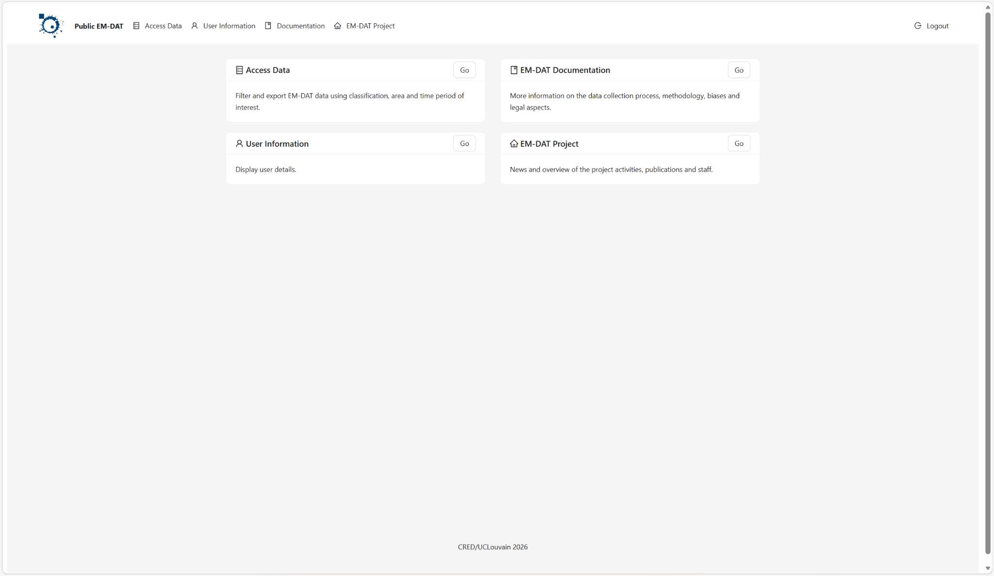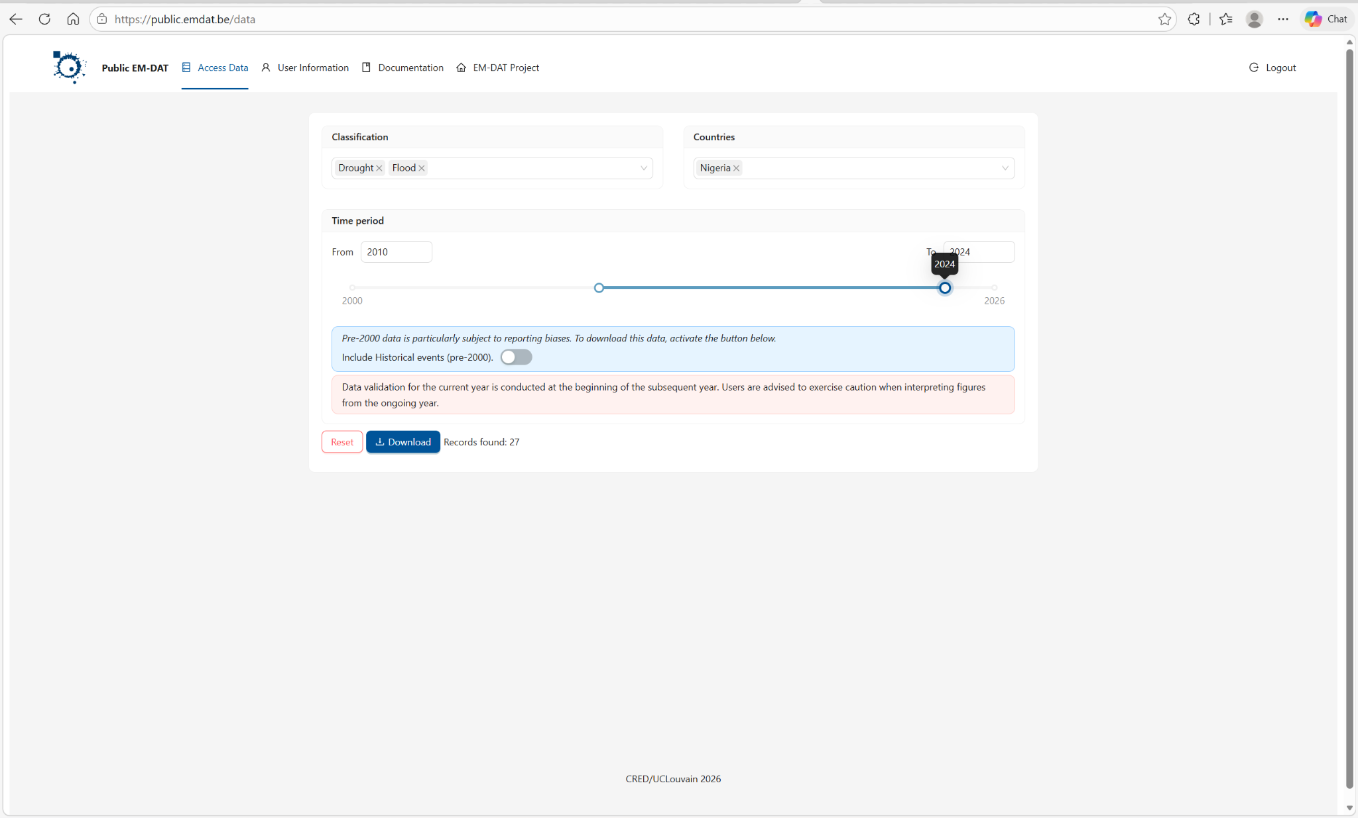

Was sourced From Centre for Research on the Epidemiology of Disasters
Database: EM-DAT International Disaster Database

